Logic
Intro to Logic
Every logic is comprised of a formal language for making statements, and a formal system for reasoning about certain objects.
(English cannot be used here as it is not formal and can be ambiguous)
Our objective is to carry out precise and rigorous arguments about assertions and proofs, and to implement these arguments and proofs. We need a language with a precisely described syntax which does not introduce any ambiguity in the meaning or semantics behind it.
What is logic?
Once the formulae of a logic have been defined, there is
- A system of deduction by which proofs can be constructed (a proof system)
- A notion of meaning by which the truth/falsity of a property can be determined (its semantics)
We will study propositional logic and first-order/predicate logic.

A logic has 3 components:
- Syntax -> definition of the formulae of the logic
- Semantics -> association of meaning and truth to the formulae
- Proof System -> maths stuff to manipulate formulae according to a system of rules
We would like all true formulae to be provable (completeness), and for all provable formulae to be true (soundness). We also want to check whether a formula is true or provable using a computer.
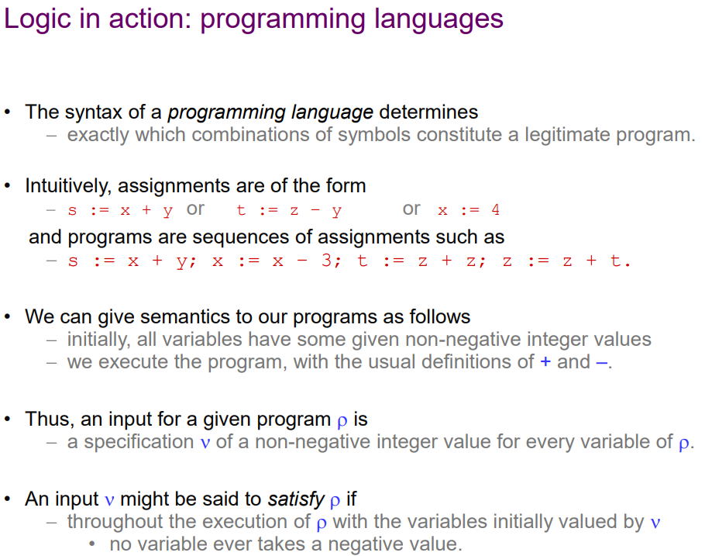
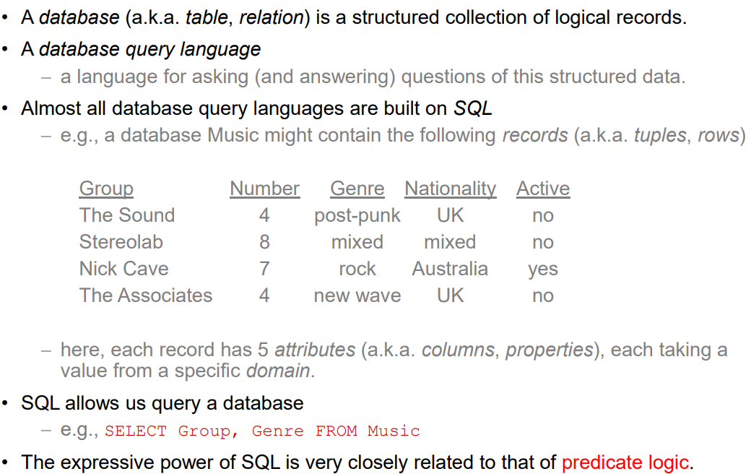
Databases are closely related to predicate logic:
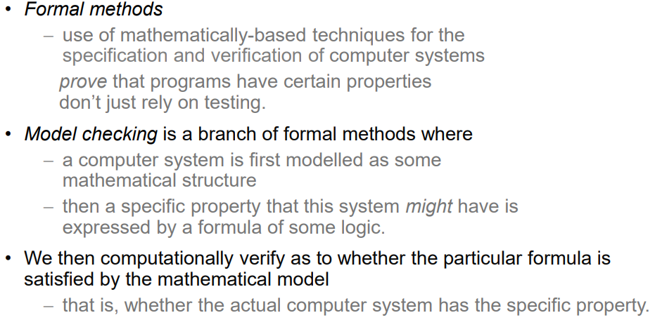
Formal methods are another example of logic in action:
Model checking is used in microprocessor design, operating systems, validating protocols, and even for NASA space program.
Propositional Logic
Propositional Logic is the most fundamental logic and formalises common sense reasoning.
The key to propositional logic are propositions – declarative statements that can either be True or False. Propositions are represented by propositional variables (usually represented by letters) which can take a value T or F.
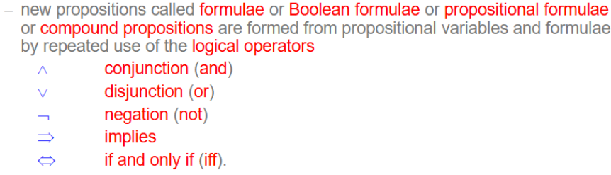
Syntax:
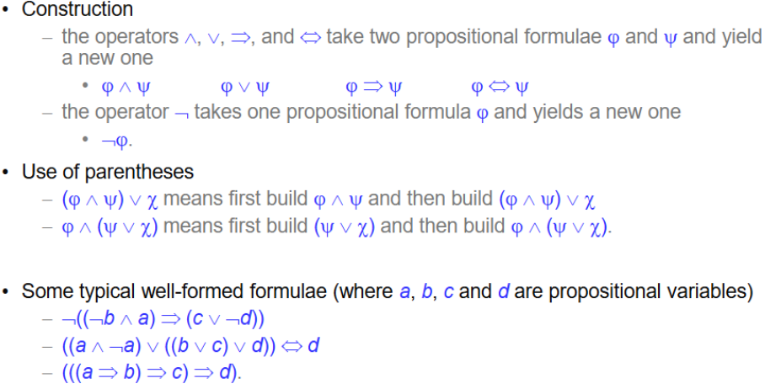
Construction of formulae:
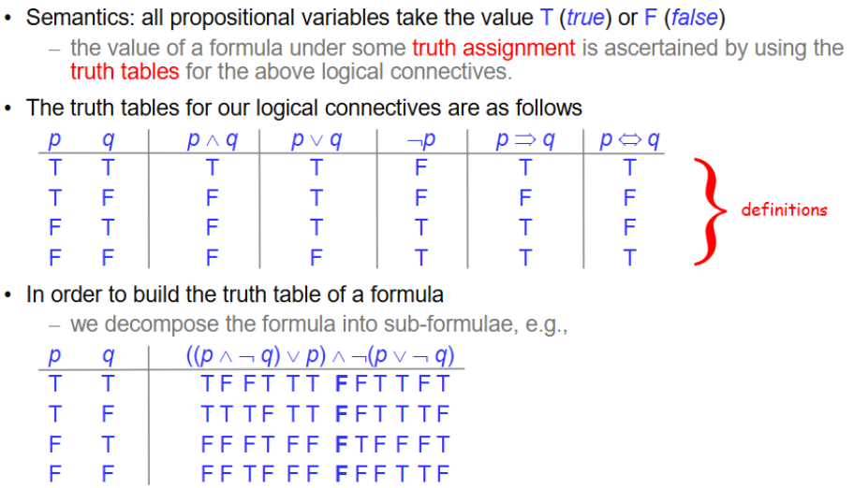
Semantics of propositional logic:
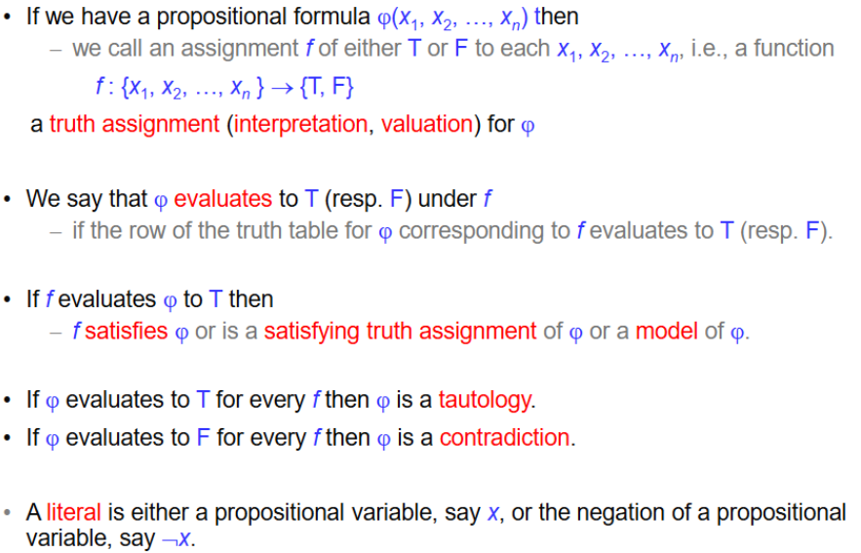
Basic notation:
Logical equivalence – steps in a proof are often just the replacement of one statement by another equivalent statement.
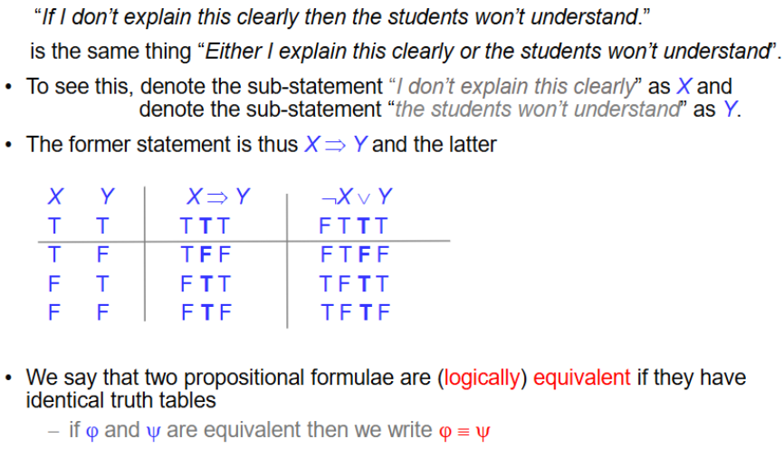
e.g. XOR has the same truth table as the negation of iff.
De Morgan’s laws can be applied to variables and formulae
(propositional formulae usually Greek letters, variables regular letters (convention))
De Morgan’s laws -> ¬(A ^ B) = ¬A v ¬B; ¬(A v B) = ¬A ^ ¬B

(oh lovely, boolean algebra returns with a vengeance)

Generalised De Morgan’s laws:
¬(X₁ v X₂ v … v X_{n}) = ¬X₁ ^ ¬X₂ ^ … ^ ¬X_{n}
¬(X₁ ^ X₂ ^ … ^ X_{n}) = ¬X₁ v ¬X₂ v … v ¬X_{n}
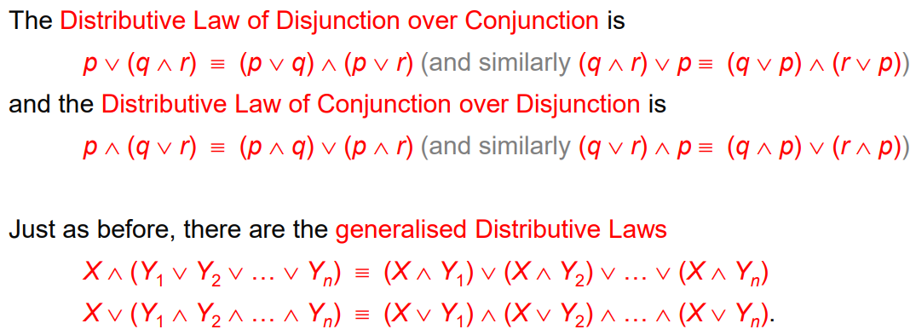
A set of logical connectives is functionally complete if any propositional formula is equivalent to one only using the connectives from this set, e.g. {^, v, ¬} is functionally complete.
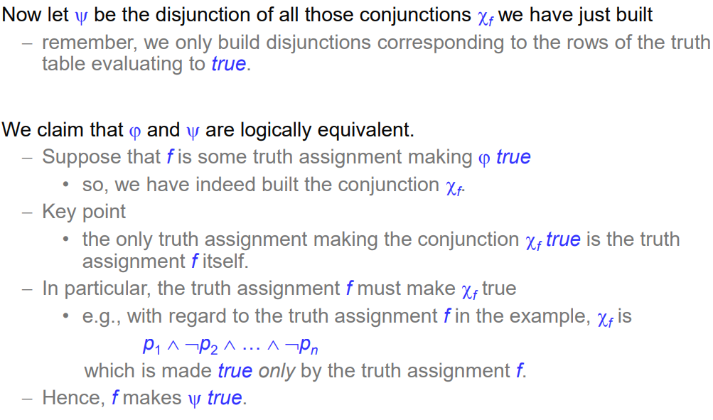
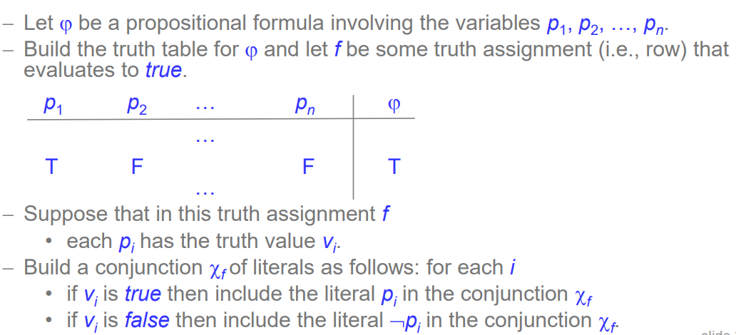
(this is waffle for sum of products – called Disjunctive Normal Form)
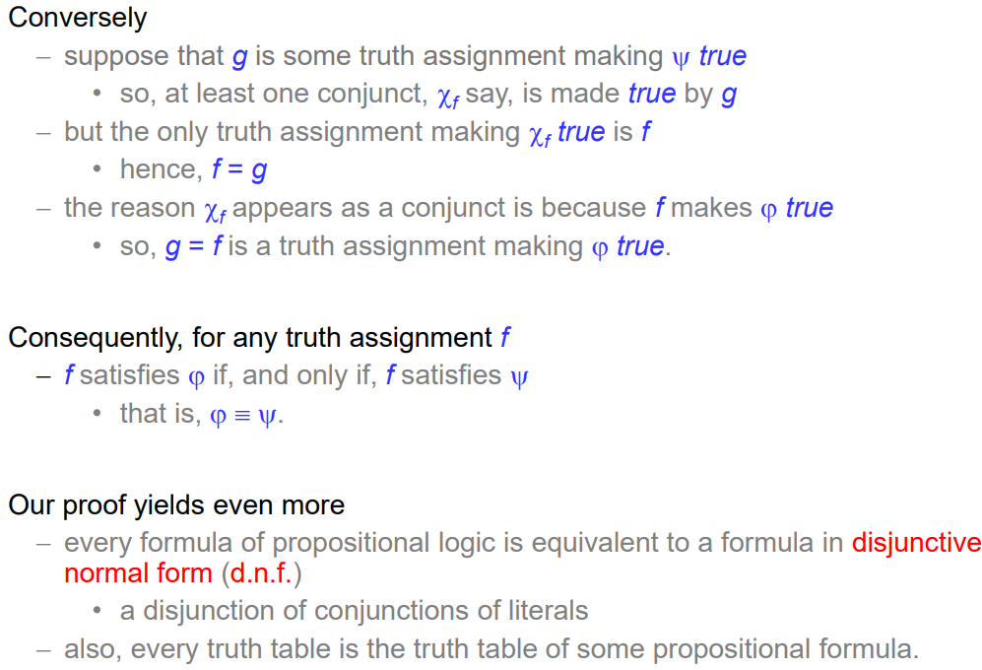
Conjunctive Normal Form -> Product of sums.
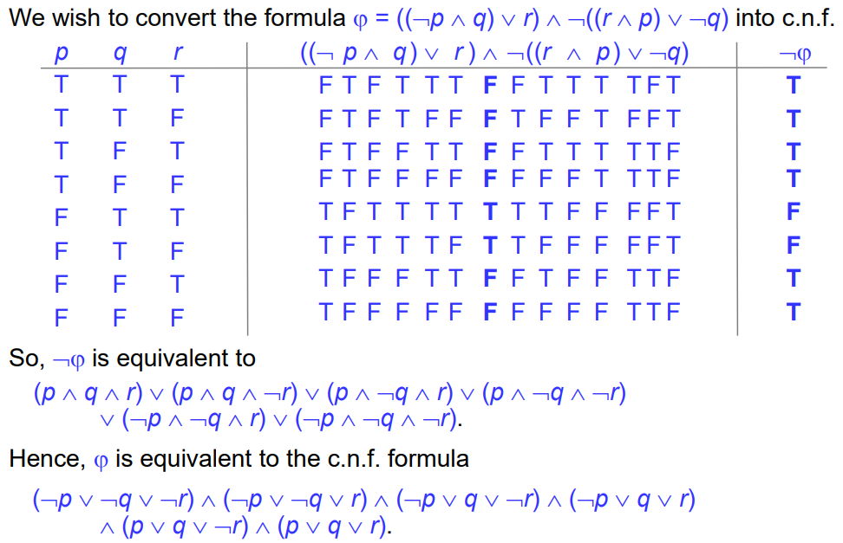
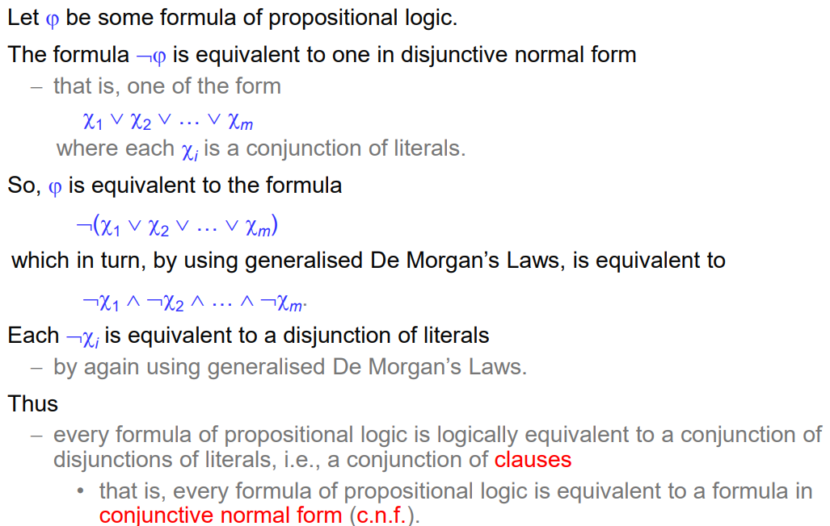
^literally just comp systems
We can also do this without using big ugly truth tables, using Boolean algebra.

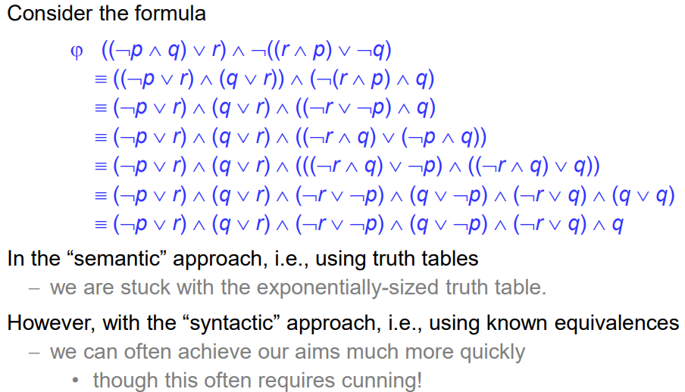
Note can simplify further: (¬p v r) ^ (¬r v ¬p) ^ q
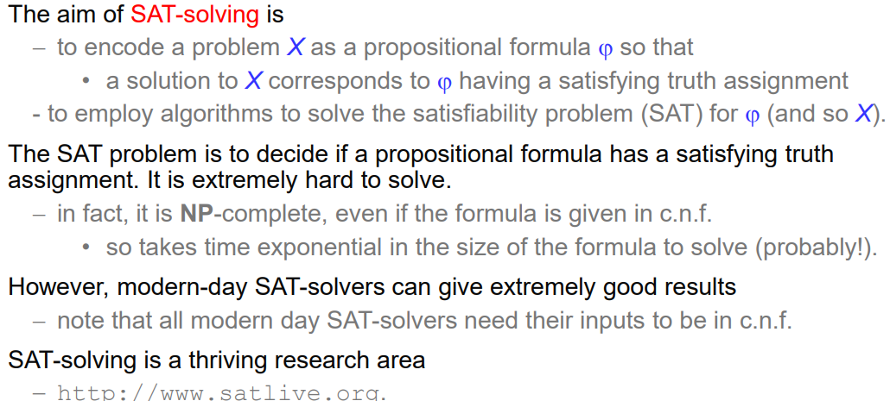
Application: SAT solving.
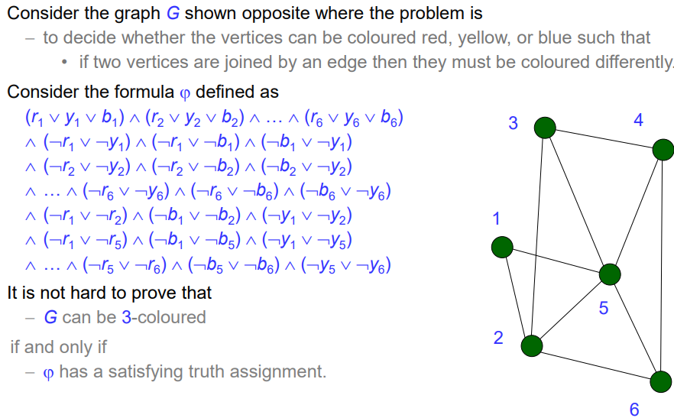
Example:
If r₁ is True, then vertex 1 is coloured red, etc for b = blue, y = yellow.
First line = each vertex has at least one colour (same for any graph)
Lines 2-4 = no vertex can be 2 or more colours. (same for any graph)
Lines 5-7 = no edge can have the same colour at both ends, going through all edges of this particular graph.

A clause is a non-tautological disjunction of literals (e.g. doesn’t contain true statements such as p v ¬p).
If every clause contains exactly k literals, then we obtain the k-SAT problem. K-SAT is polynomial time solvable for k = 2, but NP-complete for k >= 3
The (k,s)SAT problem is one where every clause contains exactly k distinct literals, and every variable appears in at most s clauses. It is known that every instance of (3,4)SAT is satisfiable and that there exists an instance of (3,9)SAT that is not satisfiable.

Proof Systems for Propositional Logic
A proof system should enable us to prove all tautologies (completeness) and all theorems proved by our proof system should be tautologies (soundness).
A proof system defines the proofs of the system – is a collection of rules of interference, which can be used to infer new formulae from old.
Propositional logic consists only of formulae built using ^, v, ¬, =>, <->
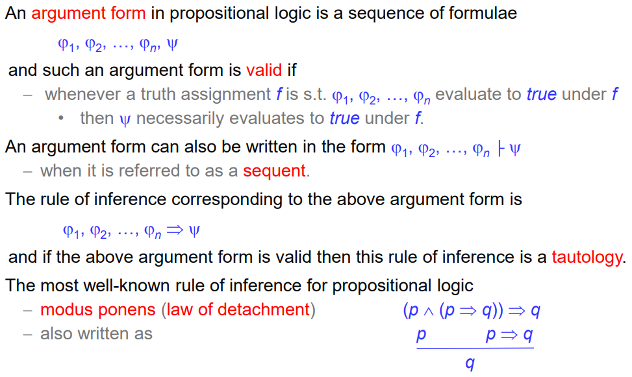
^
Horizontal line = |- = “derives”

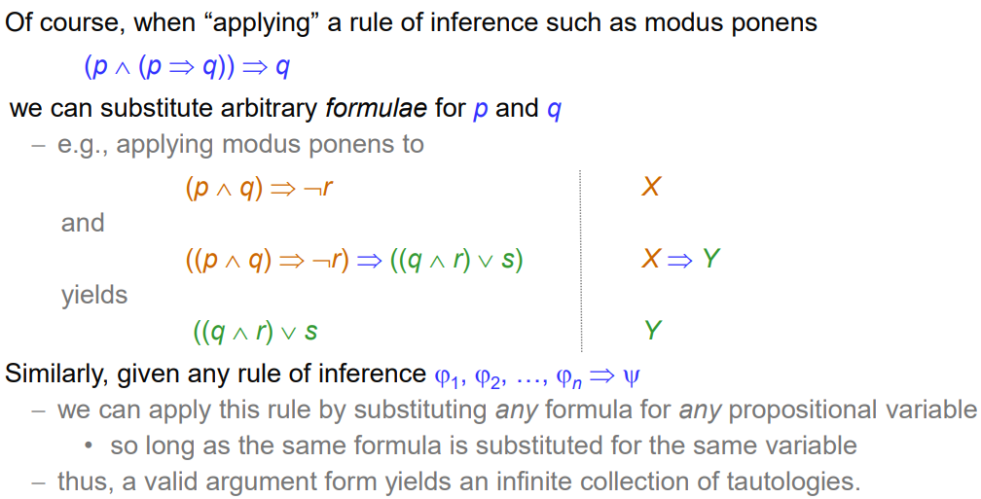
Any tautology can give rise to a rule of inference. E.g.:

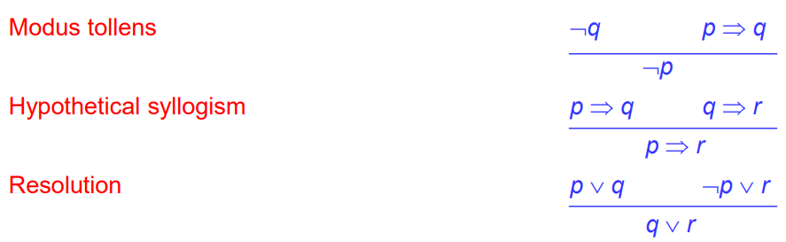
We could use a truth table for all possible truth assignments to prove something, but that could be impractical with an exponentially large number of truth assignments, so the proof theoretic approach is more efficient.
Natural Deduction:
This is a proof system consisting of a collection of valid rules of inference and is used to obtain proofs of sequents of the form q₁, q₂,…,q_{n} |- w
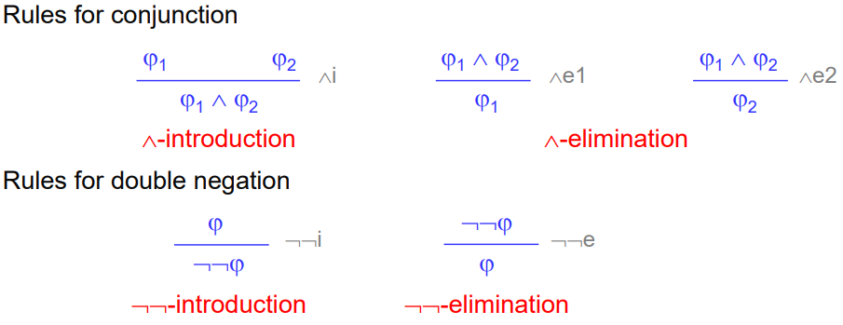
Assuming q₁, … are given as premises.
Note: “^-introduction” is true going from bottom to top as well as top to bottom, but for others (and in general) truth only goes downwards.

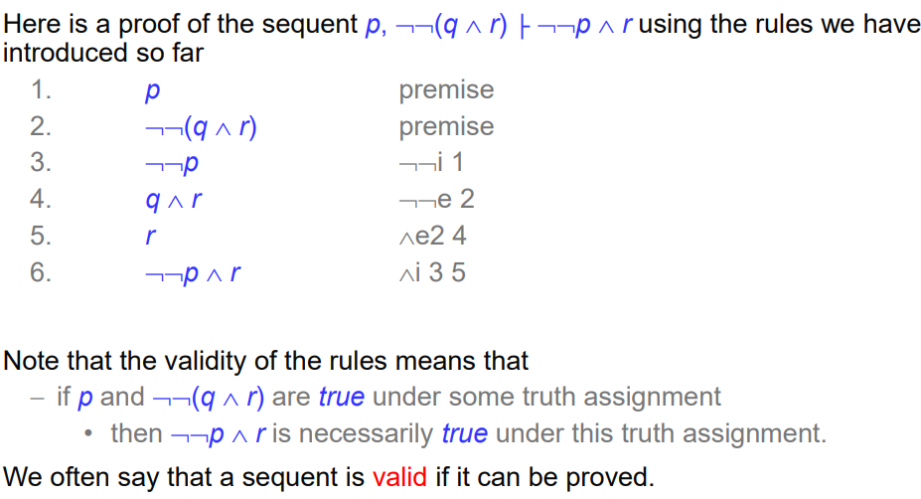
More rules (implication):
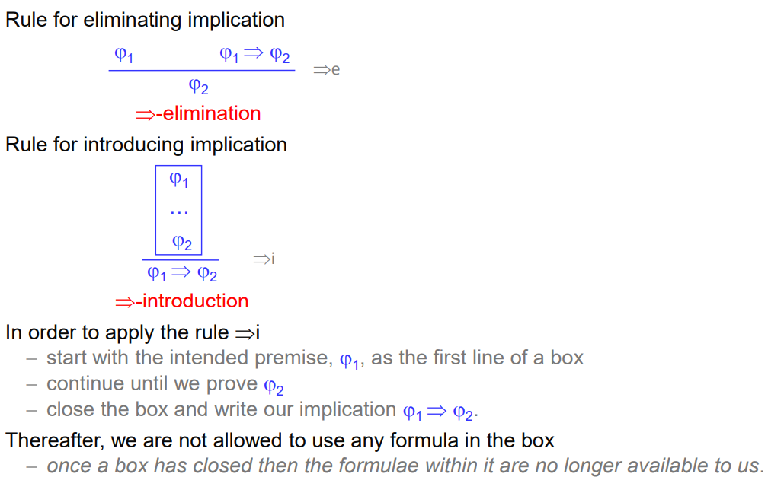

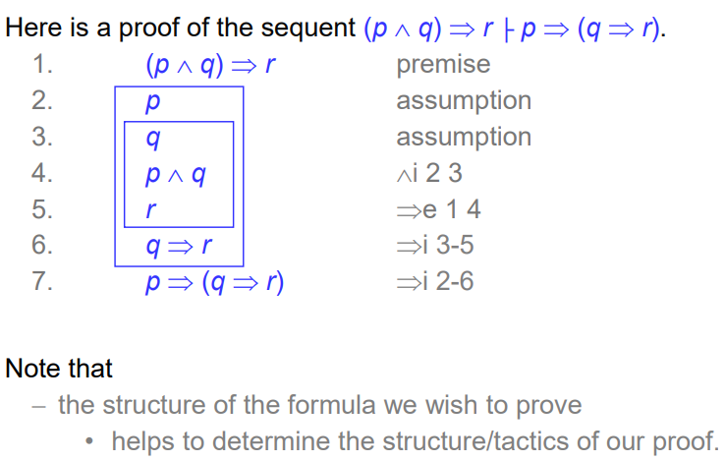
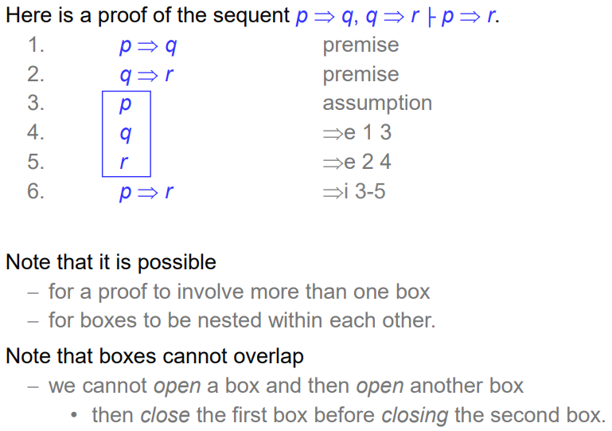
(what)
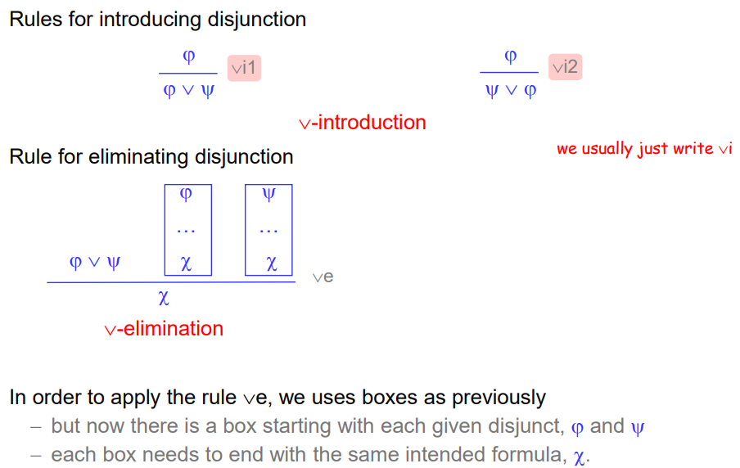
Rules for disjunction:
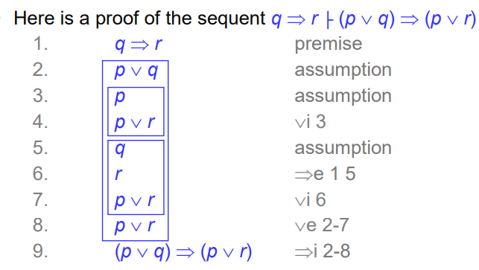
Example:

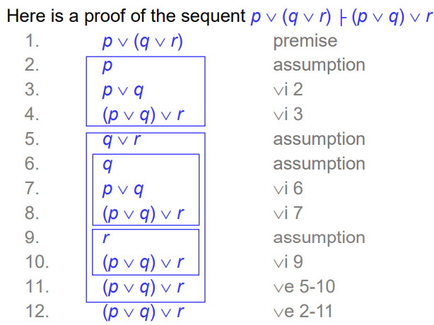
v-associativity proof by natural deduction:

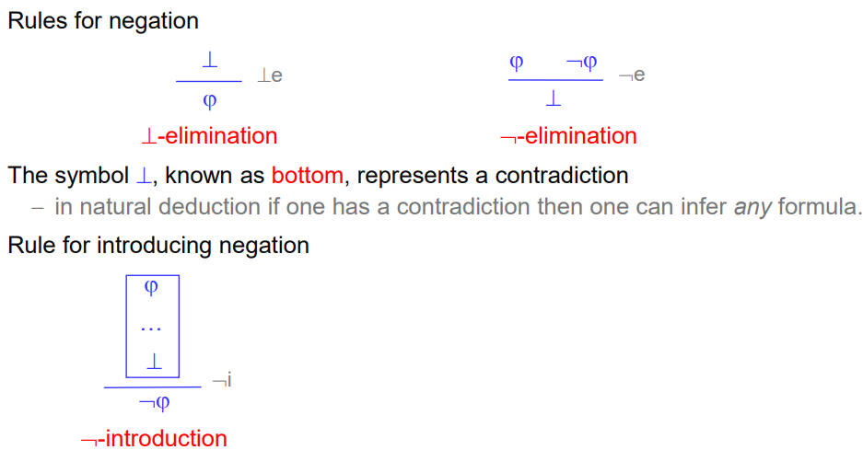
Rules for negation:
^If you can derive a contradiction by assuming ϕ, then we have proved ¬ϕ.
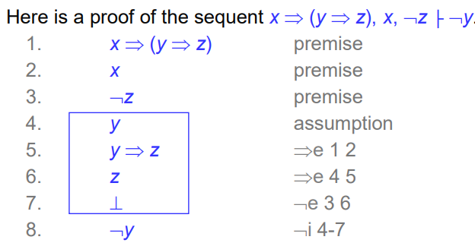
Example:
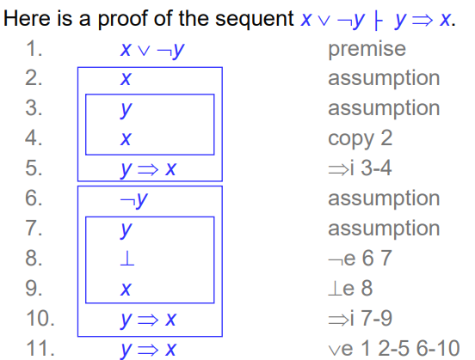
Example 2:

We can derive rules in natural deduction, and use them as if they are rules of natural deduction.

Proof by Contradiction:
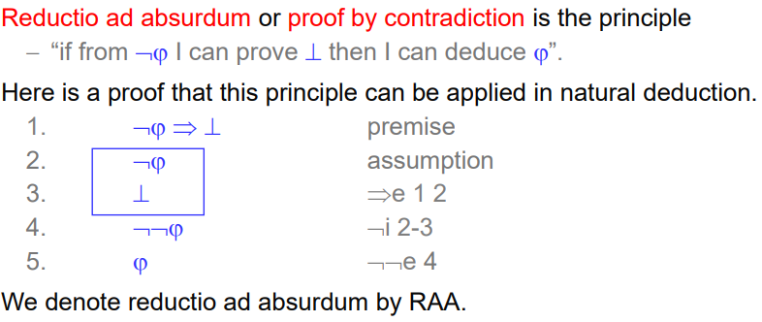
a

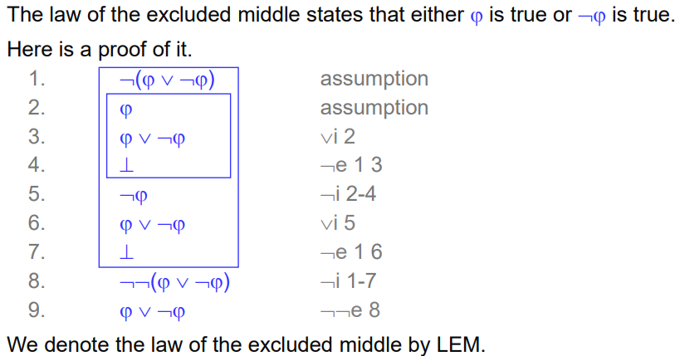
Law of Excluded Middle (LEM):
^can prove sequents without any premises

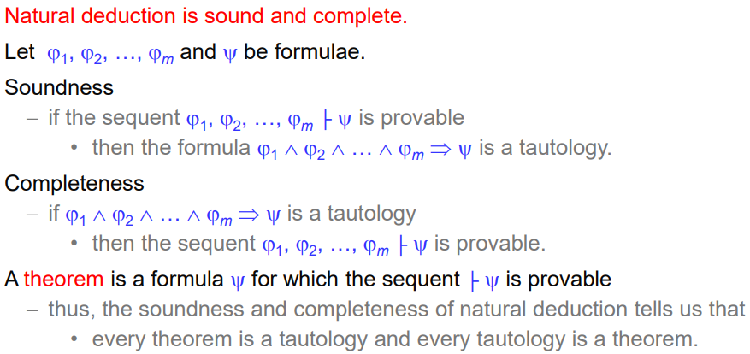
Natural deduction facts:
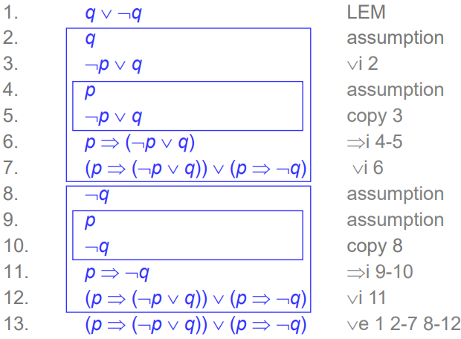
Theorems can be proved using LEM, e.g:
Resolution
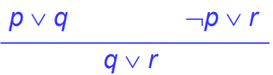
Resolution is a proof system based around the rule of inference:
In general:

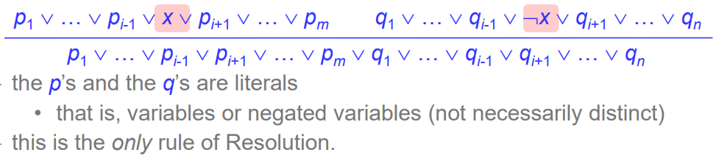
While natural deduction proves theorems from scratch, Resolution takes a given formula and works with it to decide whether or not it is a theorem.

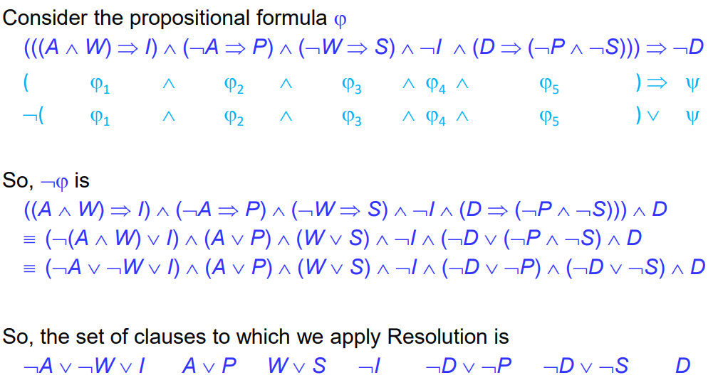
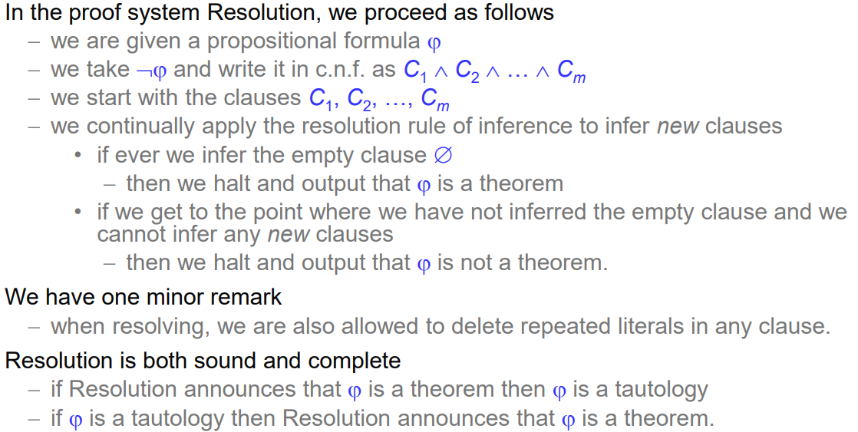
Example:
(C₁ ^ C₂ ^ … ^ C_{n}) => X is true iff (C₁ ^ C₂ ^ … ^ C_{n} ^ X) is a contradiction.
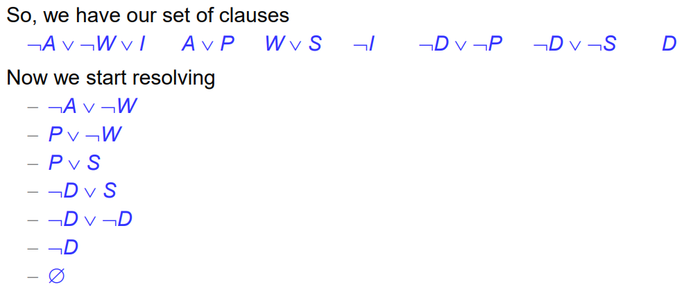
(keep screwing around with the clauses until you get an empty disjunction)
Note – has to be in conjunctive normal form first -> need a conjunction of disjunctions, which means turning implies etc into AND and OR.
If you infer all new clauses and do not arrive at an empty disjunction then we have proved something is not a theorem and not a tautology.
Resolution works by taking the negation of a formula ϕ that we wish to prove true, and showing that this negation, ¬ϕ, is unsatisfiable. Resolution may not always give a quick answer, and in worst case involves an exponential number of applications.
SAT solvers check whether a given propositional logic formula is satisfiable, whereas Resolution aims to prove theorems. These are two sides of the same coin: a propositional formula ϕ is satisfiable if and only if ¬ϕ is not a tautology.

SAT Solvers
Suppose we design a system which may contain many components, all of which use software. We have requirements on how the system should function, for example safety, reliability etc. We need to be able to ensure the system satisfies these requirements.
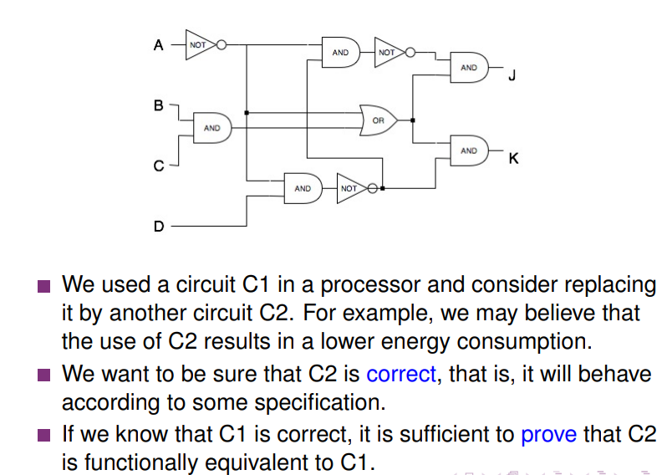
Example:
To establish correctness, we need a mathematical object to represent the system – we need to build a formal model of the system.
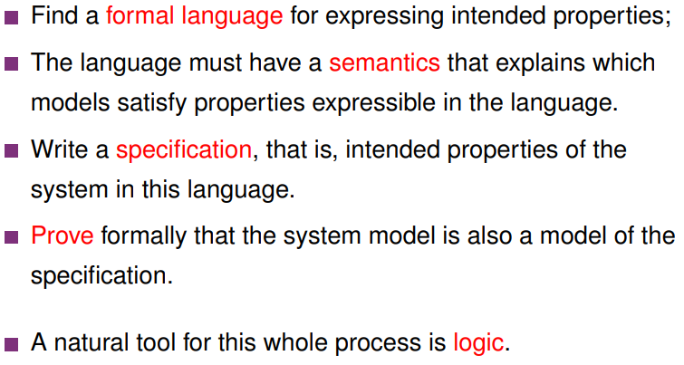
Formal proofs proceed via reasoning, we need to be able to automate reasoning.
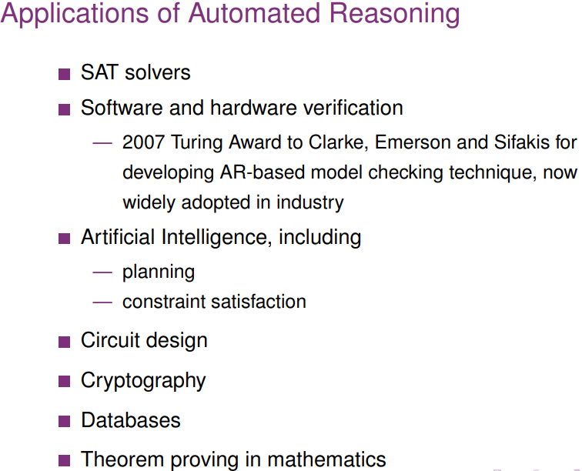
Applications of automated reasoning:

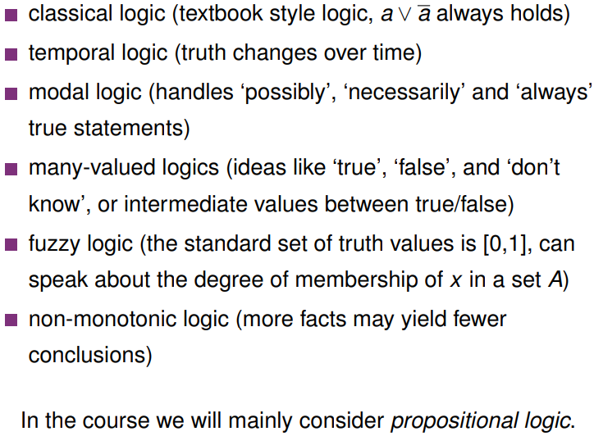
We have different logics for different applications, e.g.:

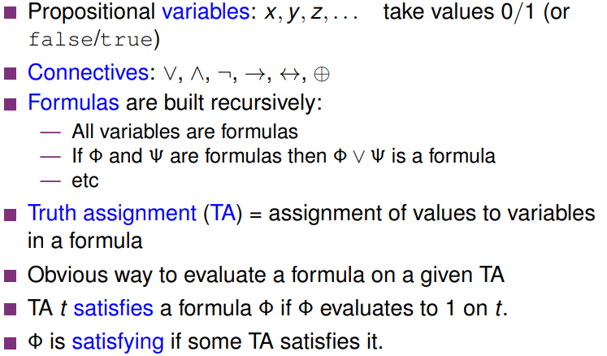
Propositional logic:

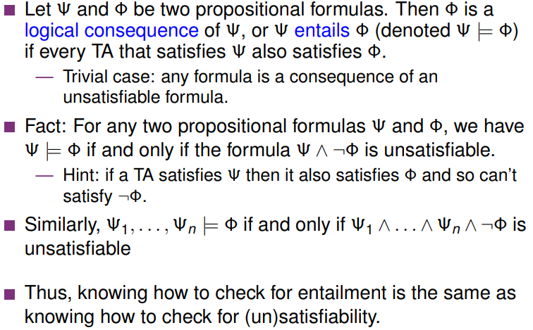
Satisfactions vs consequence in propositional logic:
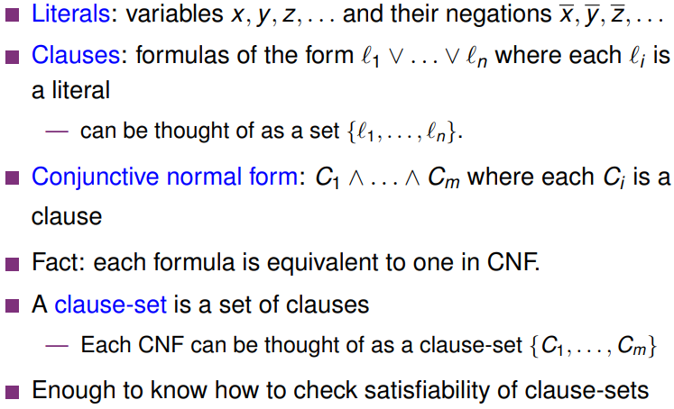
Literals and Clauses:

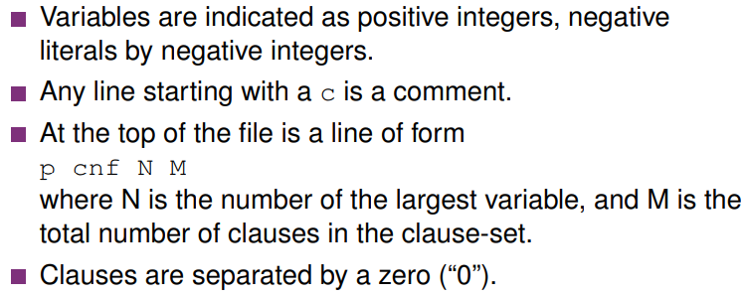
DIMACS format – text format for representing clause sets, is a standard format for most of today’s SAT solvers.

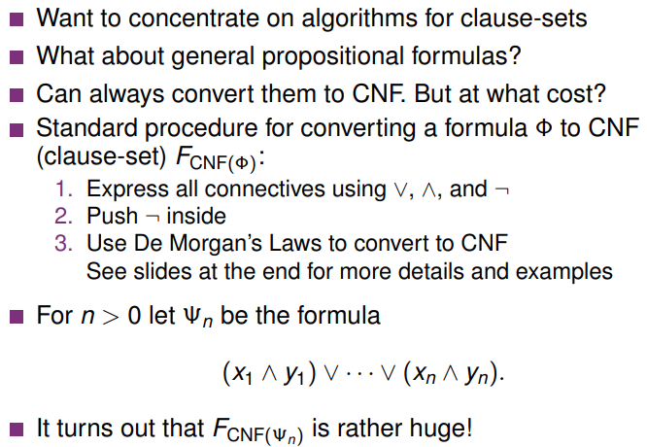
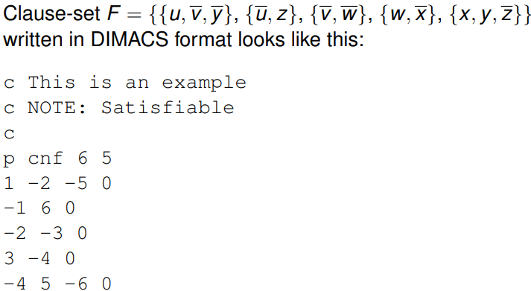
^ u,v,w,x,y,z = 1,2,3,4,5,6 in this case
To get around this issue, we can use transformations which preserve equivalence wrt satisfiability as opposed to pure logical equivalence. We can add extension variables.
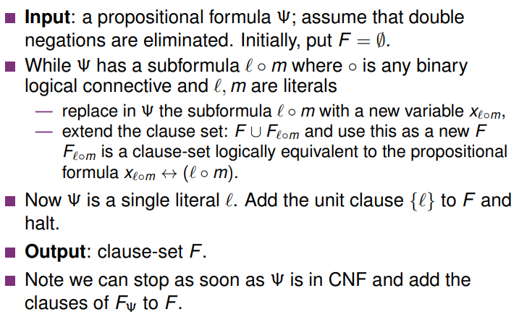
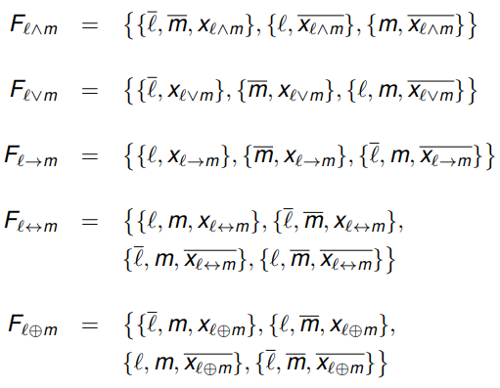
What to replace things with?

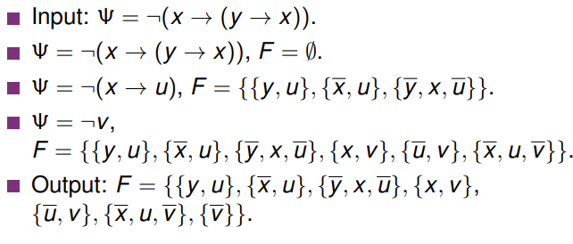
Example:

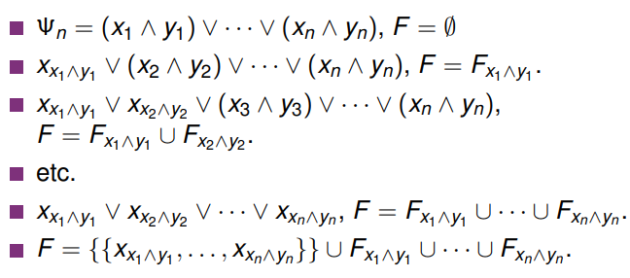
Example 2:
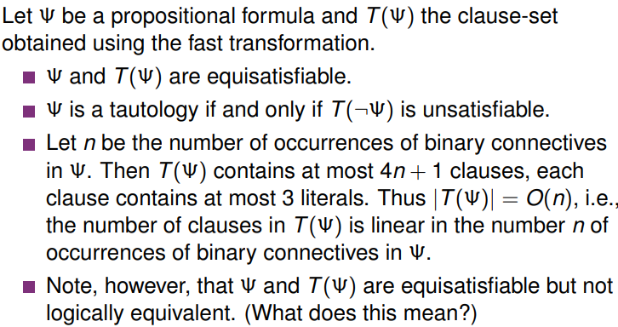
In general:

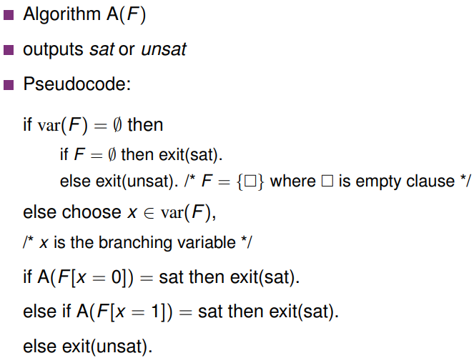
Algorithm:
^”this algorithm is exceedingly stupid” – Barny

A literal x of a clause set F is called a pure literal if some clauses in F contain x but no clauses in F contain ¬x, i.e. variable x only appears under one polarity. Pure literals can be set to true and all clauses containing them can be removed from F to result in F’. F’ is equisatisfiable to F. The smallest clause set that can be obtained from pure literal elimination is denoted by PL(F)
When a clause set F contains a unit clause {x}, we can obtain by unit propagation the clause set F[x=1], i.e. we know the literal x must be true, and can remove any clauses containing it from the clause set. We write UP(F) as this clause set, and UP(F) is always equisatisfiable to F.
For any clause set F, we have UP(PL(UP(F))) = PL(UP(F)), and it can be proved that there is a clause set F s.t. PL(UP(PL(F))) != UP(PL(F)). So we do UP followed by PL when simplifying clause sets.
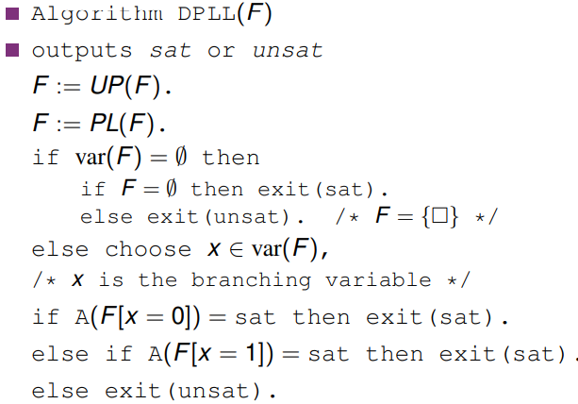
Improved, less stupid algorithm:

Clause learning:
CDCL (conflict driven clause learning) caches clauses and learns them. Learnt clauses allow us to reduce the search space later on.

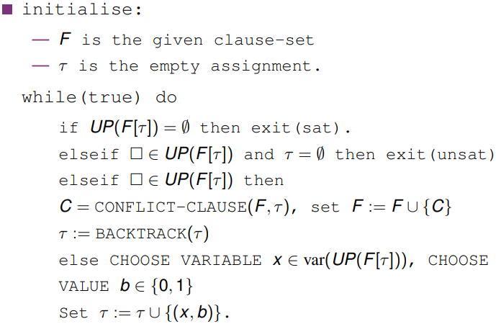
a
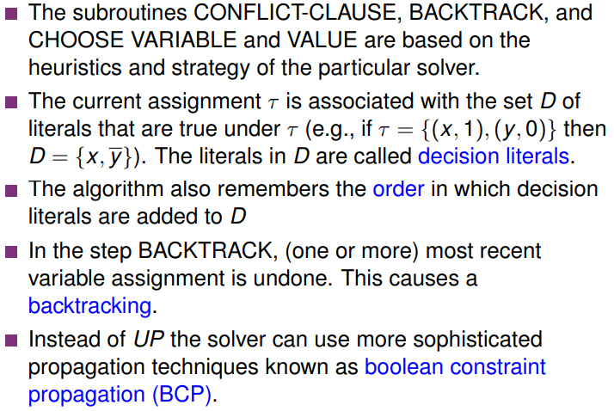
Note:

Variable choice heuristics: favouring variables which occur in many small clauses. The majority of a SAT solver’s runtime is spent doing UP.


First-Order Logic
The fundamental building block of propositional logic is the propositional variable, whereas in first-order logic it is the predicate. A predicate symbol is a symbol with an associated arity, e.g. P might be defined as a predicate symbol of arity r. (arity = number of variables in the predicate)
Given predicate symbol P of arity r and variables x₁, … , x_{r}, the formula P(x₁, … , x_{r}) is an atomic formula in first-order logic. In order to know if this formula is true or false, we need to be given an r-ary (e.g. unary, binary etc) relation P’ over some domain D and values v₁, … , v_{r} from D for x₁, … , x_{r}.
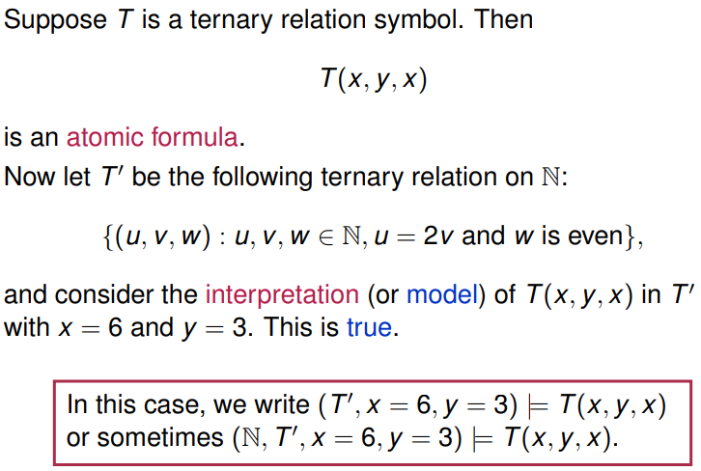
Example:
^ interpretation -> is T(6,3,6) a member of set T’. This is true.
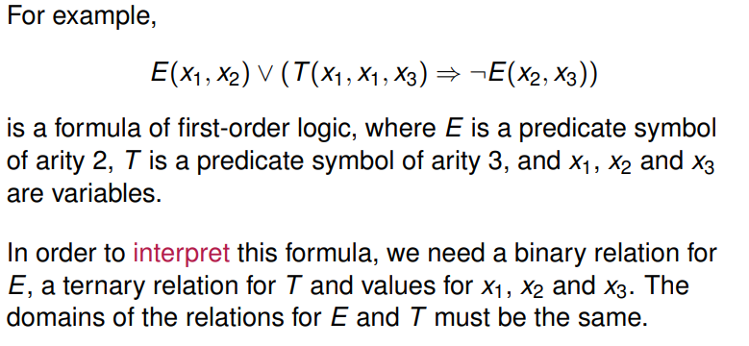
We can use the connectives from propositional logic to build more complicated formulae from atomic formulae.
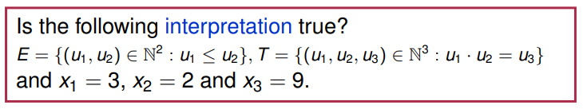
^we can call interpretations and the predicate symbols by the same letter because we do not care enough to differentiate them syntactically even though they are very much different.
E(3,2) is false
T(3,3,9) is true since 3 * 3 = 9
E(2,9) is true, so ¬E(2,9) is false
T(3,3,9) => ¬E(2,9) is True => False which is False
So the overall interpretation is false.

We also allow formulae of the form x=y where x,y are variables, which is only true if the value of x equals the value of y in an interpretation.
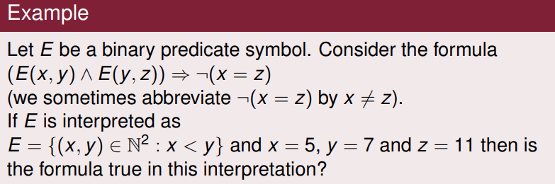
(E(5,7) ^ E(7,11)) => ¬(5=11)
(True ^ True) => True
True
Formulae that are built from atomic formulae are called quantifier-free formulae, and variables that appear in a formula are called free variables. We can quantify over free variables using the “for all” and “there exists” quantifiers.
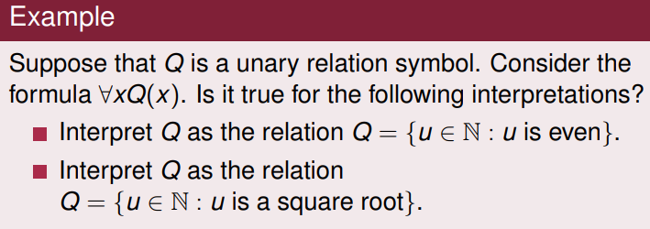
^ Not all numbers are even so the first Q is false
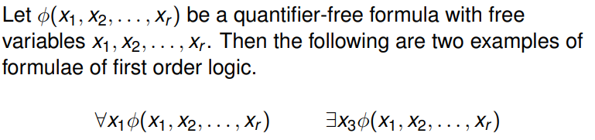
Every natural number is the square root of another natural number (itself squared) so the second Q is true.
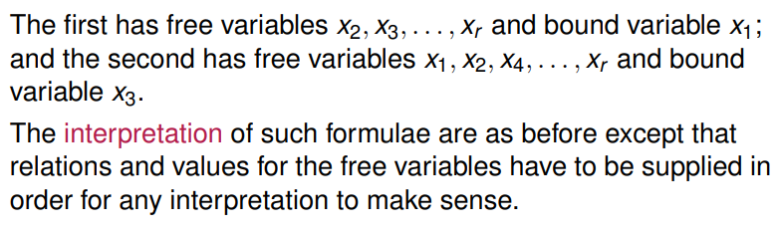
(not all free variables in a formula need quantifiers applied to them.)
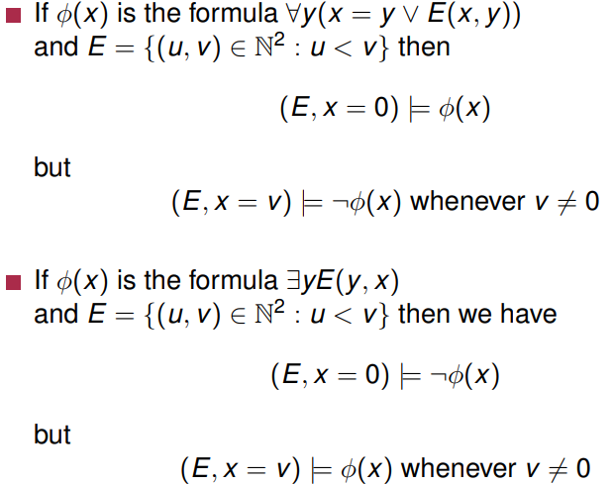
Example:
^ When x = 0, x=y when y = 0 and E(x,y) is true for all y > 0 so ϕ(x) is true for x = 0, but for any x > 0, y is not greater than x for all possible y in N, so the formula is false for all other x = v, v != 0.
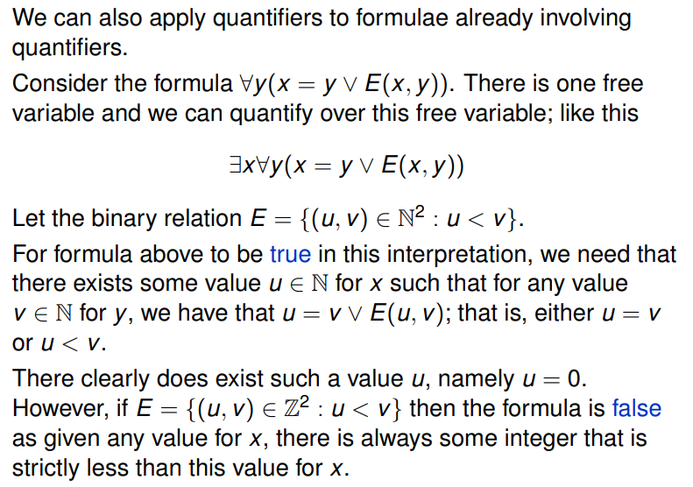
Example:
^There does exist an x such that for any y in N that either x < y or x = y, so this formula is true over the domain N, however not true for domain Z since there is no minimum element in Z.

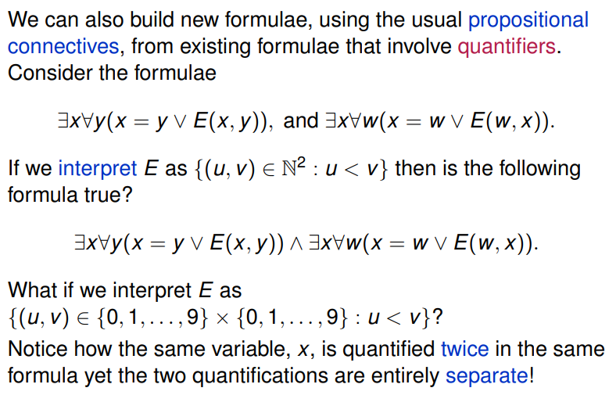
Example 3 (oh god):
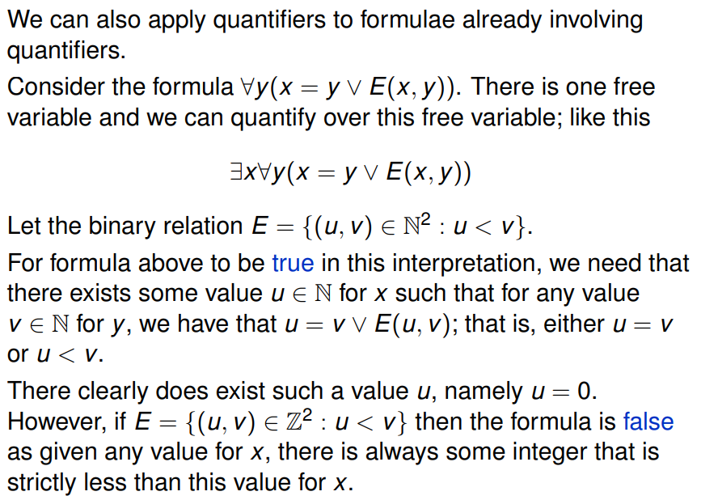
We can also add quantifiers to free variables in preexisting formulae
We can also build new formulae by joining together existing formulae that have quantifiers, using propositional connectives.

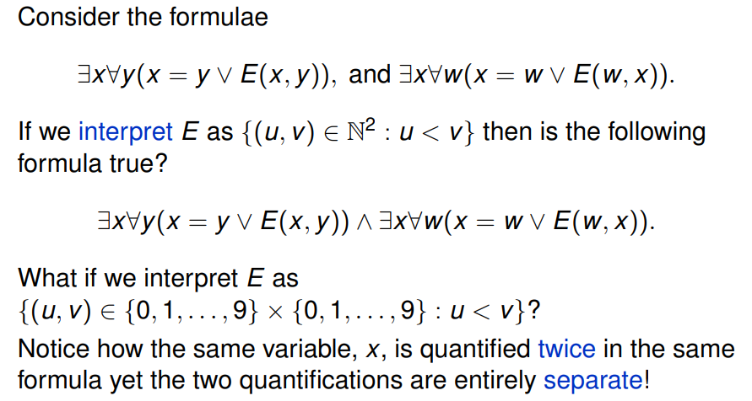
Syntax of first order logic
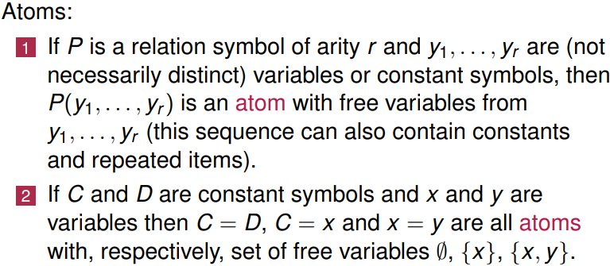
Every formula of first order logic is constructed from atoms. We define the logic of first order logic by defining what we mean by atoms and the constructions we are allowed to use.
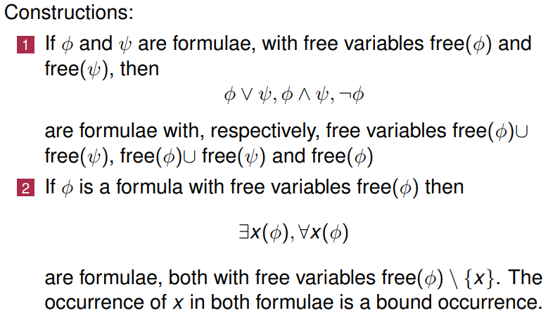
If a formula has no free variables, then it is called a sentence.
∃x(y=y) -> False
∀x(y=y) -> True
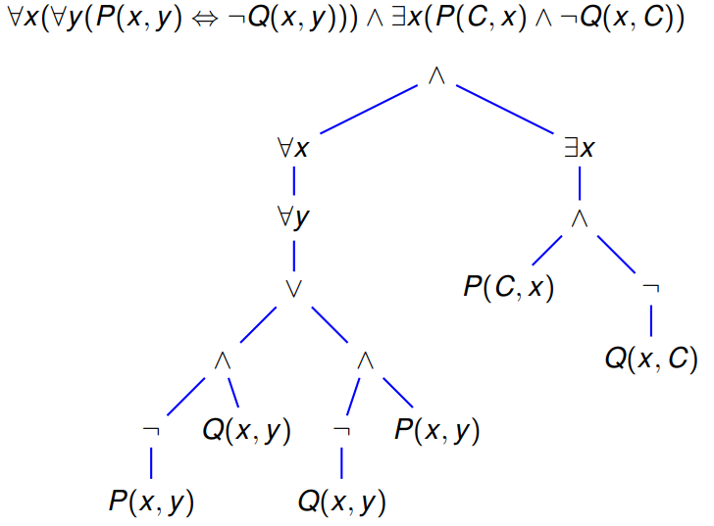
Parse Trees:
^Note <-> is expressed in terms of ^, v and ¬ in the parse tree.
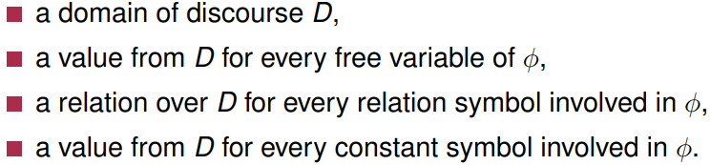
An interpretation or structure for a first order symbol ϕ is:

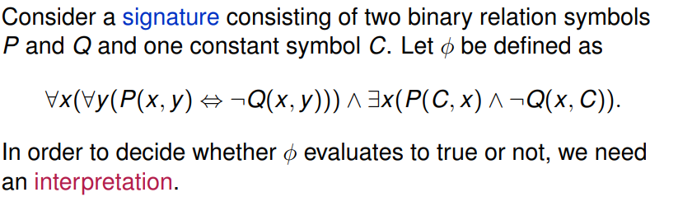
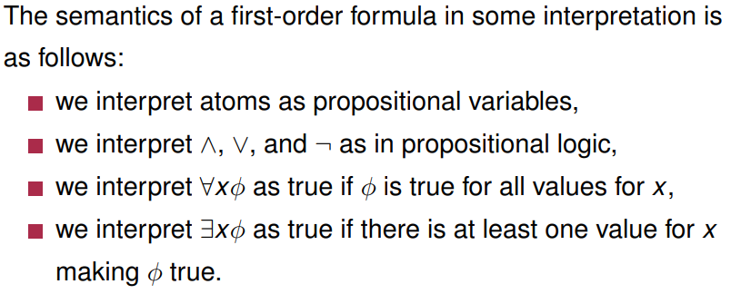
Example:

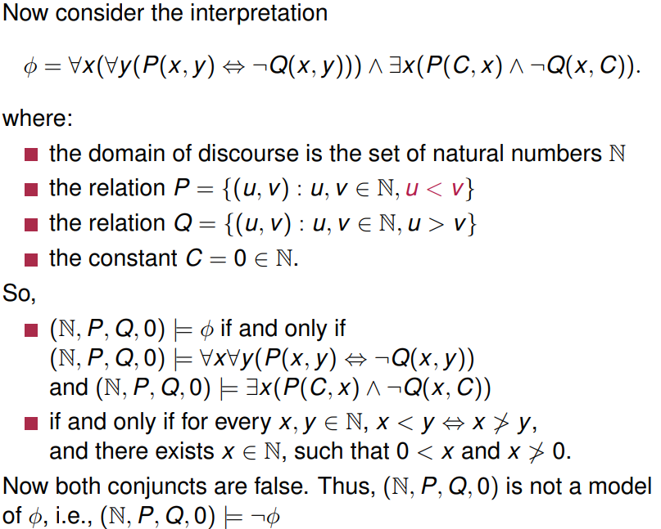
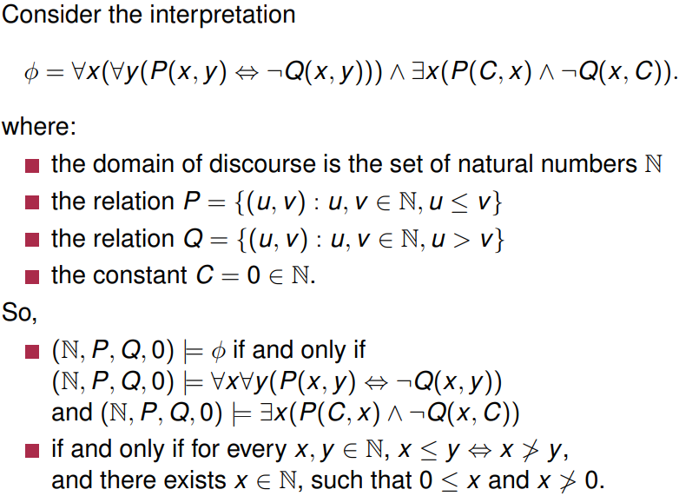
Different interpretation:
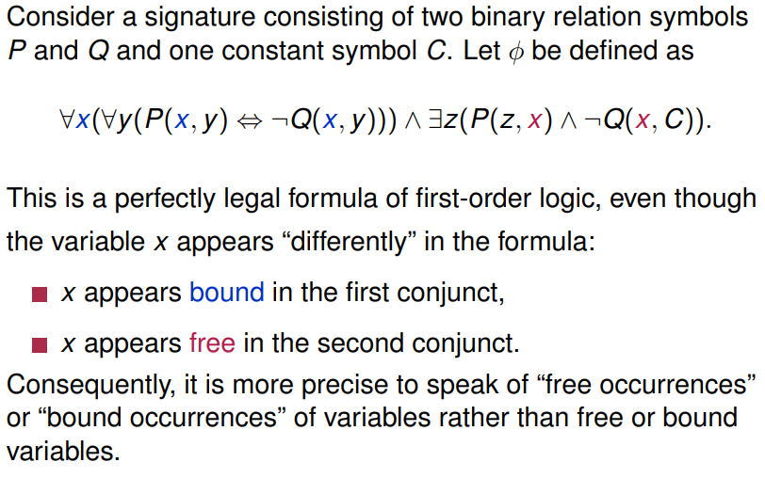
Subtleties:
^Bound instances of variables can be renamed with no effect of the logic of the formula.
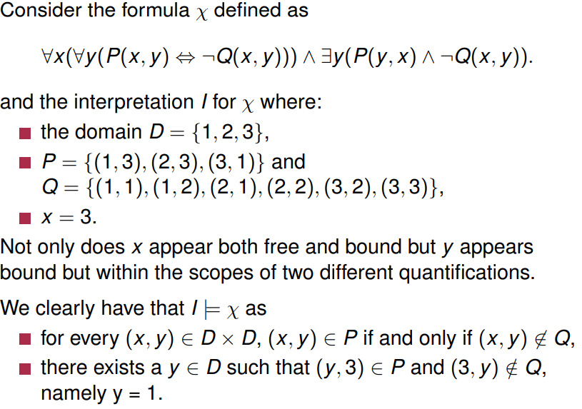

(i have no idea whats going on anymore)
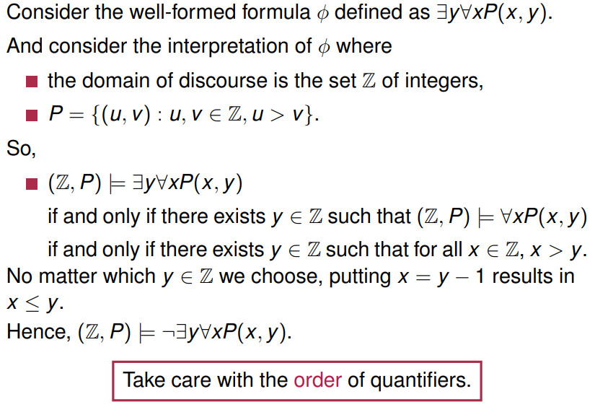
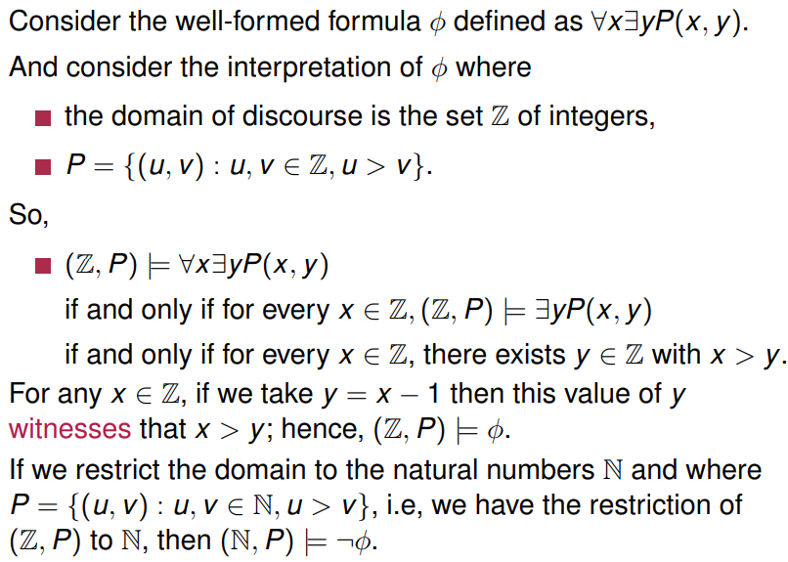
a

Logical Equivalence:
Two formulae ϕ and ψ are logically equivalent if they are true for the same set of models. All logical equivalences in propositional logic give rise to equivalences in first order logic, e.g.
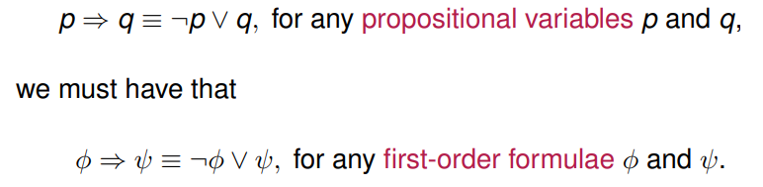
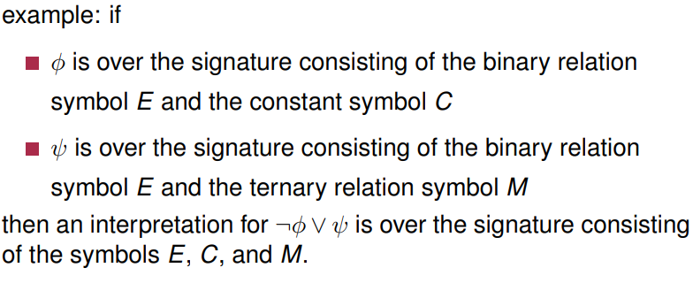
Note we must take care as to exactly what an interpretation is when we plug in formulae:

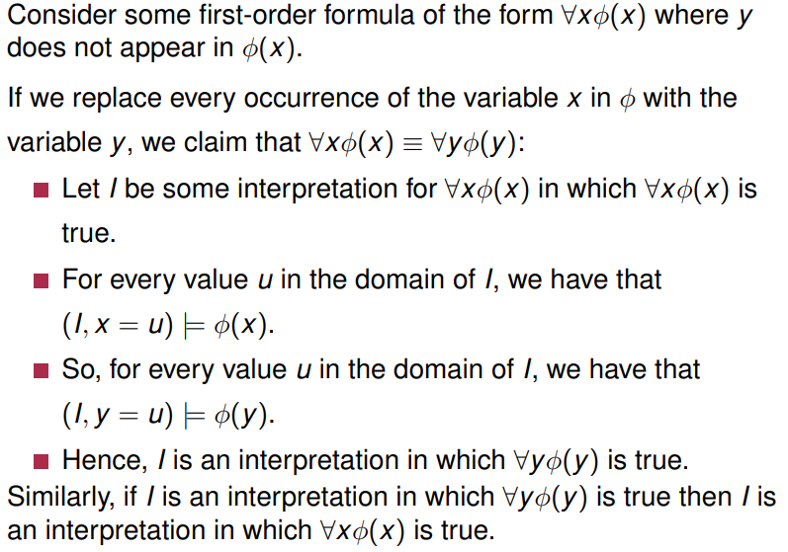
Renaming variables:
^basically don’t rename your variable to the name of another variable that exists in the same formula
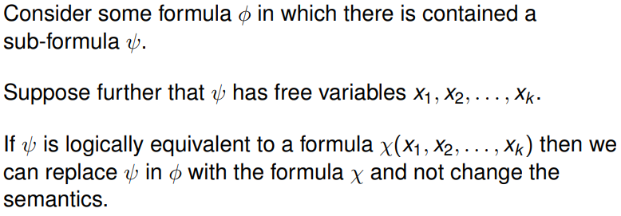
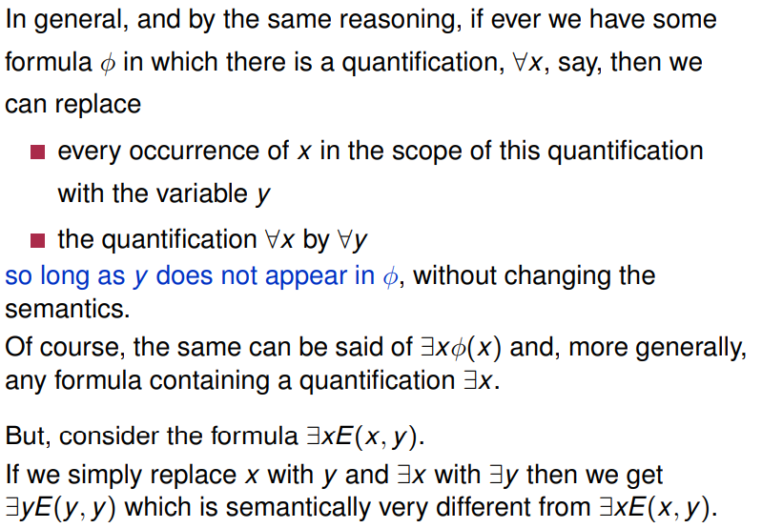
Substitution:

Common equivalences:
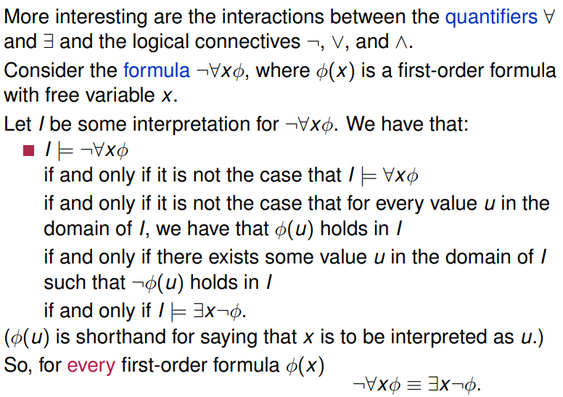
^ not(forAll(x))phi() = thereExists(x)not(phi())
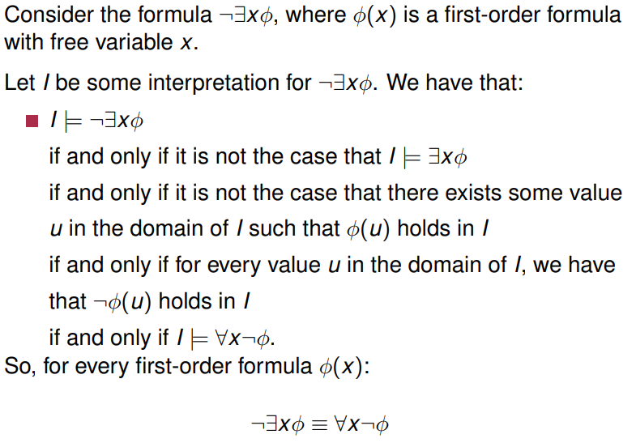
^not(thereExists(x))phi() = forAll(x)not(phi())
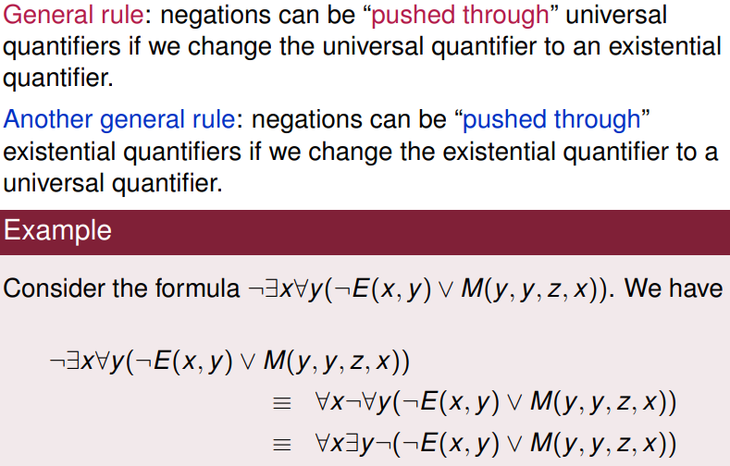
In general:

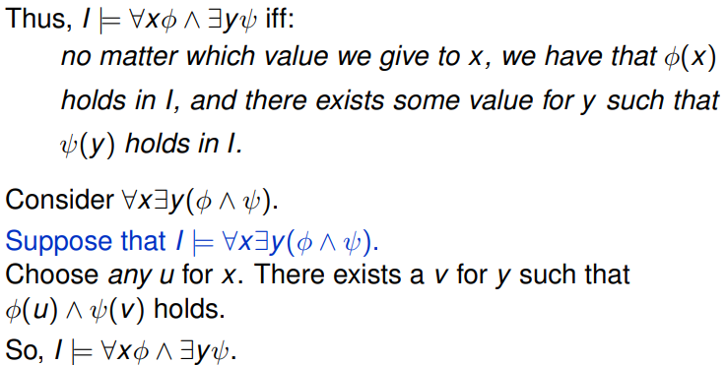
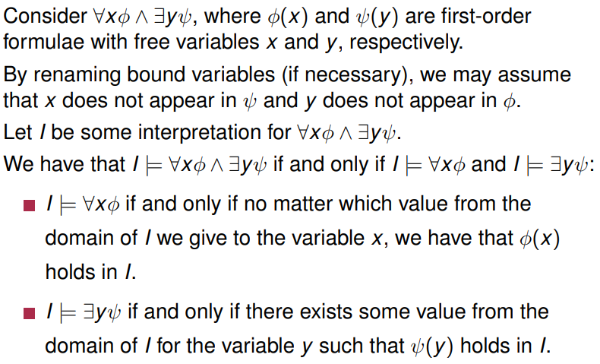
More complicated examples:
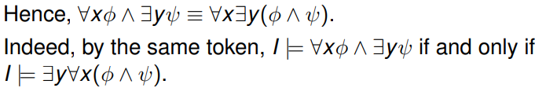
^remember y needs to not be in ϕ and x not in ψ for this to work.
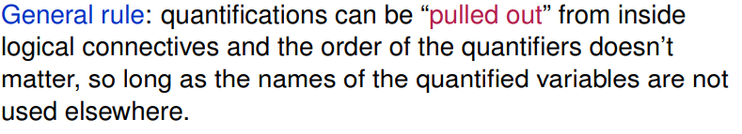
In general:
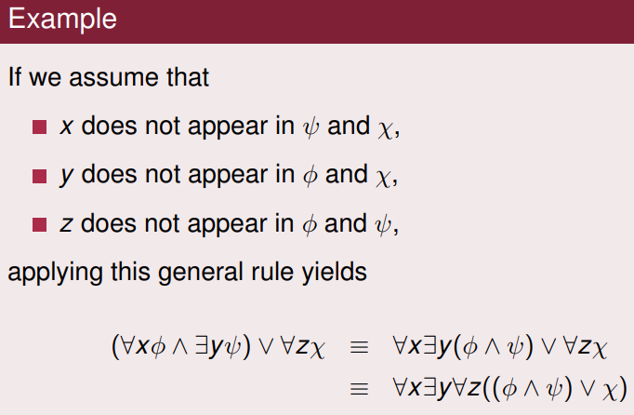
Example:
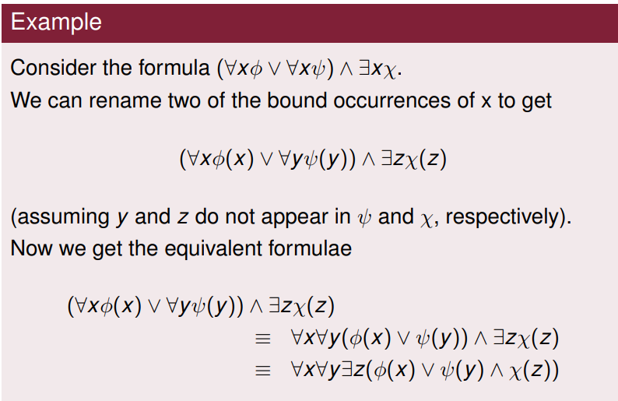
Example 2:

Note: have to be careful, order of quantification matters, and need to consider occurrences of quantified variables outside of the quantifier scope.

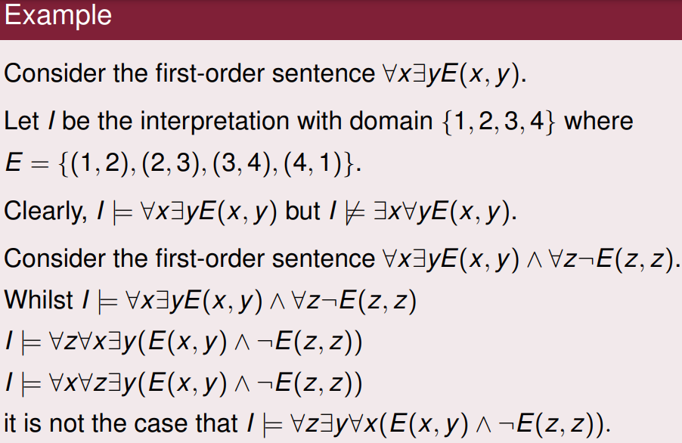
^in other words, forAll(x)thereExists(y) != thereExists(y)forAll(x)
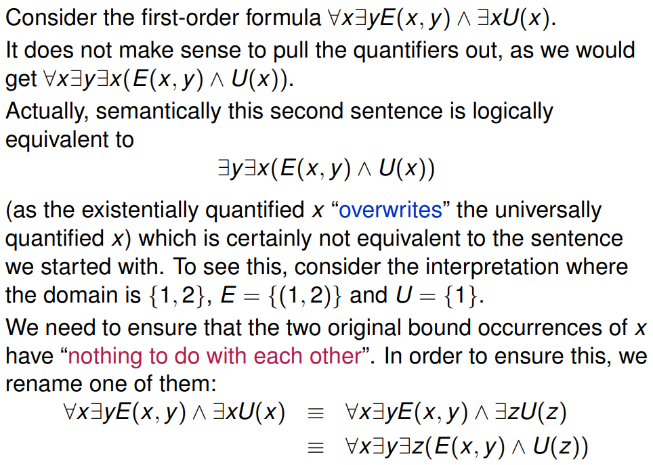
^basically rename your variables where possible so as to not create conflicts which break the logic

Two formulae φ and ψ are logically equivalent if they are true for the same set of models. We write φ ≡ ψ. We can use a parse tree to check if a formula is well formed, e.g.

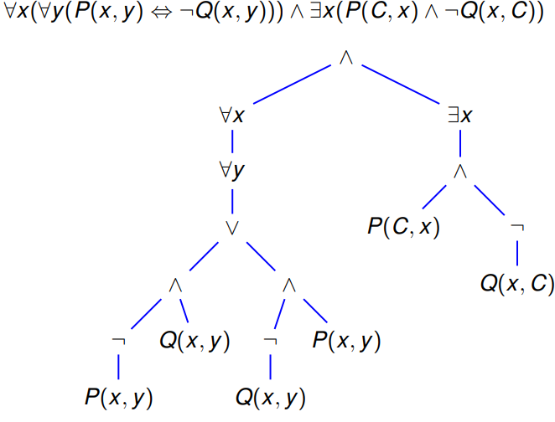
Prenex normal form:

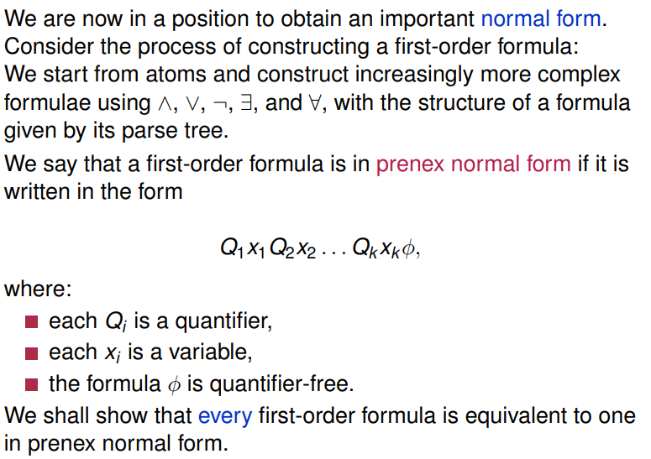
We use the parse tree of a formula to construct an equivalent formula in prenex normal form. We start at the leaves of the parse tree and work our way up.
Note: A key observation is that if we choose some node of the parse tree of φ and look at the sub-tree with this node as root then this sub-tree corresponds to a sub-formula of φ; that is, to a formula appearing as a formula within φ
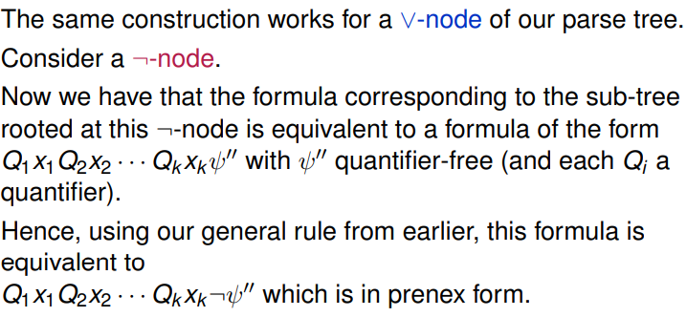
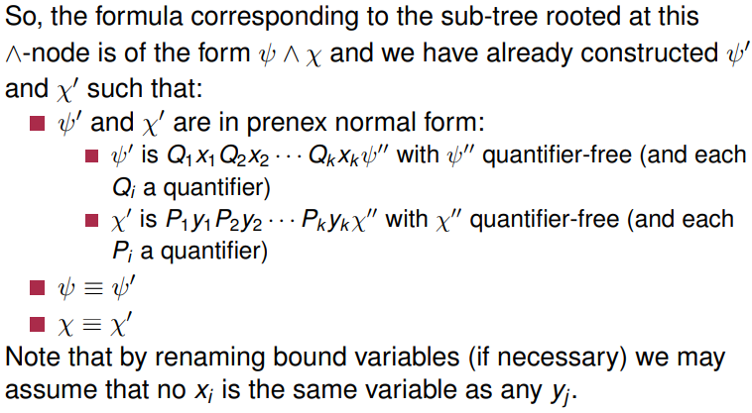
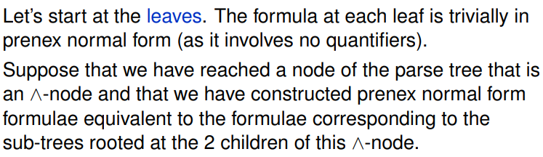
^Note the quantifiers Q₁, … , Q_{k} should be switched from forAll to thereExists and vice versa as we
are dragging a negation through them.
